Category I-RestNTravel™ Pillows:
- For NECK REST
  - 7 x 7” (150 gms) Jute/Cotton Cover Square Pillow (100₹)

  - 7 x 12” (250 gms) Jute/Cotton Cover Round Pillow (200₹)
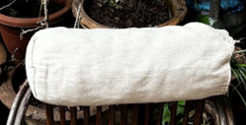

For BACK REST & SEATING:
- 10 x 10” (300 gms) Jute/Cotton Cover Square Pillow (150₹)

- 14 x 14“(450 gms) Jute/Cotton Cover Square Pillow (200₹)
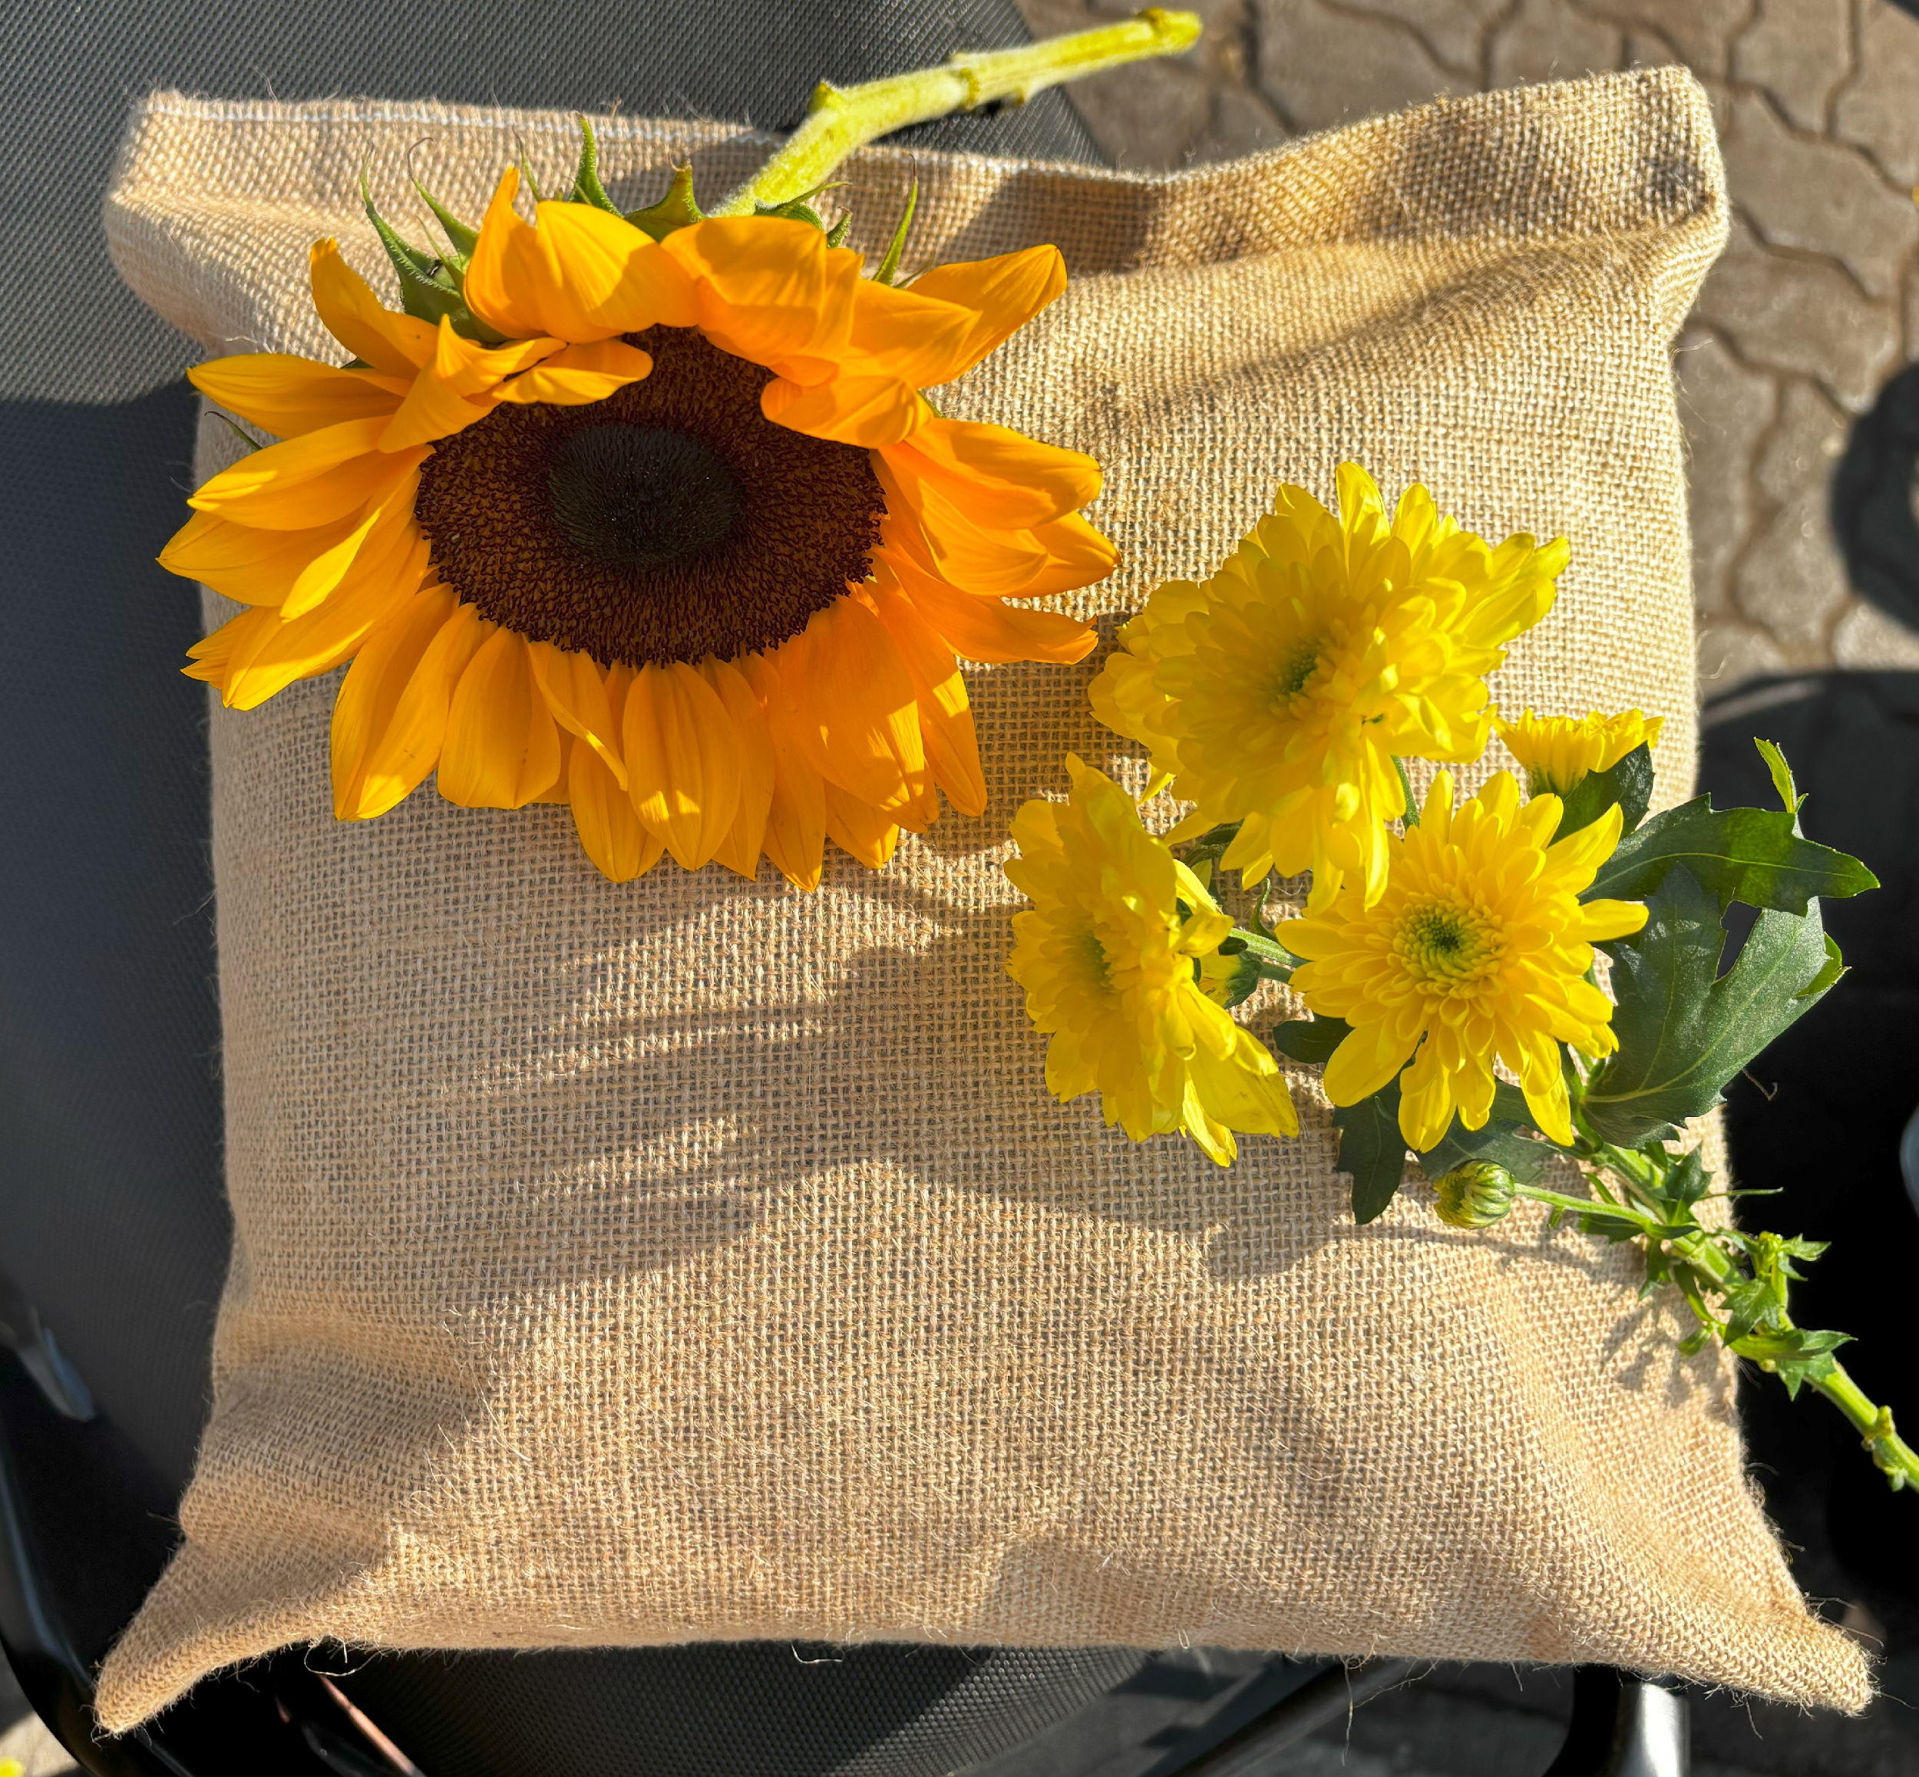
- 20 x 26” (750 gms) Jute/Cotton Triangular Pillow (300₹)
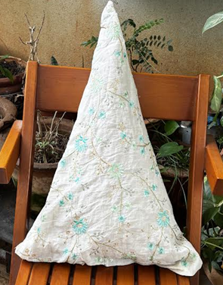
For SLEEPING:
- 14 x 22 “(750 gms) Jute/Cotton Cover Rectangular Pillow (250₹)
- 16 x 22” (850 gms) Jute/Cotton Cover Rectangular Pillow (300₹)
- 16 x 27” (1000 gms) Jute/Cotton Cover Rectangular Pillow (350₹)

Category II-RestNTravel™ Mattresses:
Single 5’x2.5’ (1500₹)
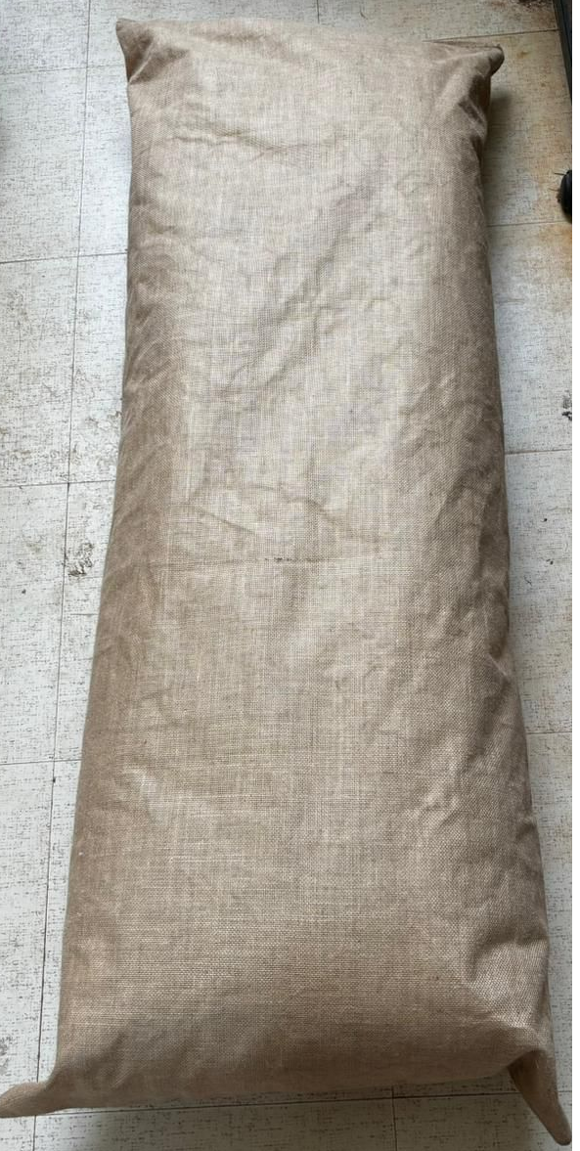
Double 6’x5’ (2000₹)
Category III-RestNTravel™ Quilts:
Single 5’x2.5’ (1500₹)

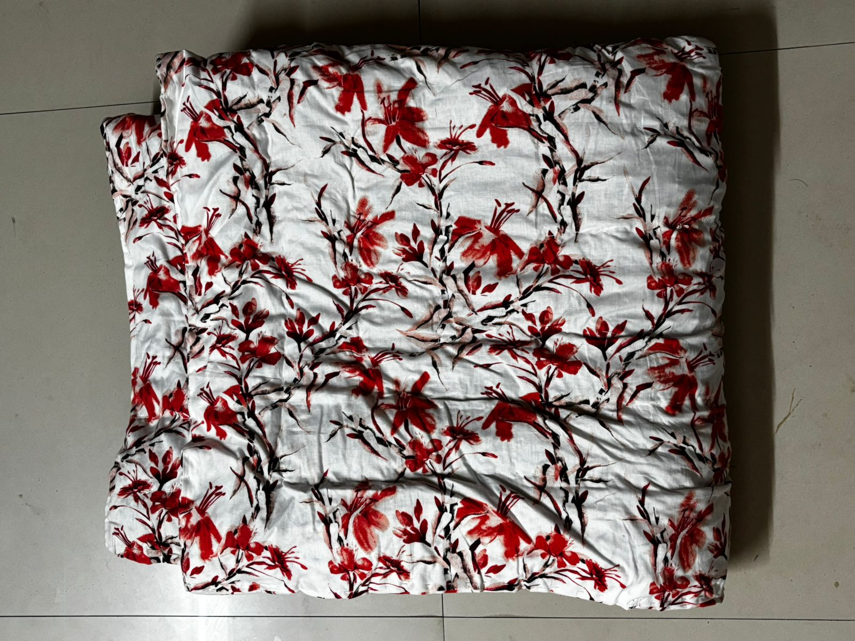

Double 6’x5’ (2000₹)
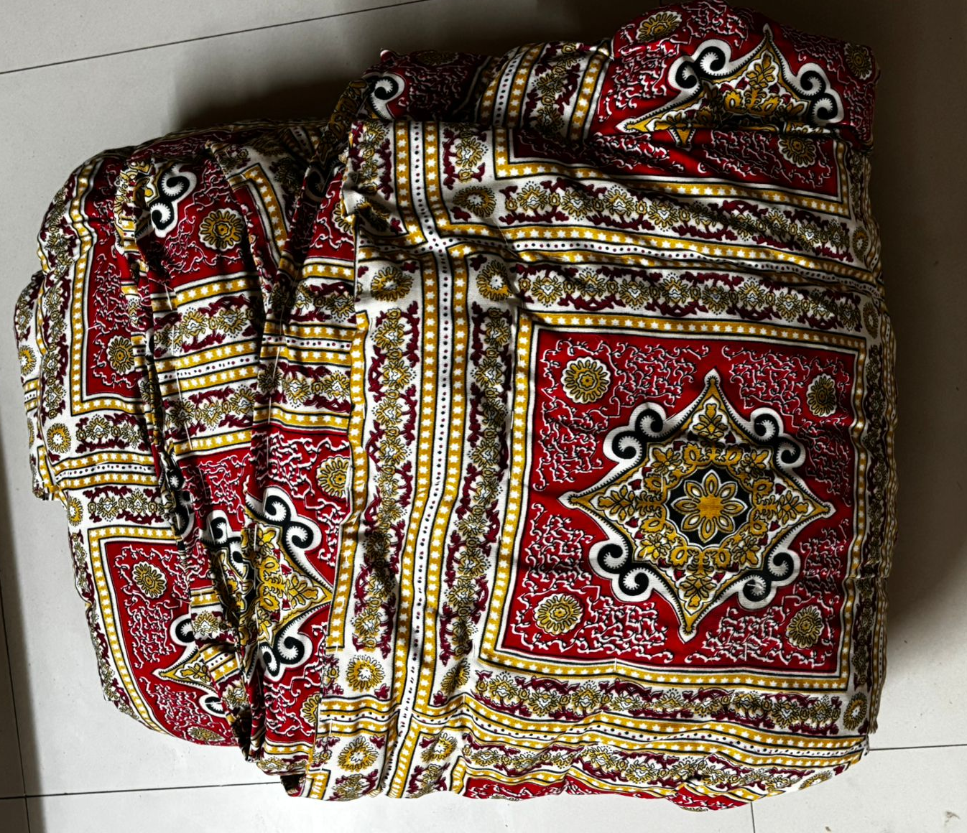
Category III-RestNTravel™ Bean bag
5’x4’ (1500₹)
